**Reg. No. 21BCE1297 Name: Vidhi Shah Date of Practical: 06/04/22**

**Experiment 6**

**Aim:**

AC and transient analysis of CE (Common Emitter) amplifier using LTSpice.

**Tools and Apparatus:**

­LTSpice, Transistor, Resistors, Capacitors, Voltage Sources

**Theory and Design:**

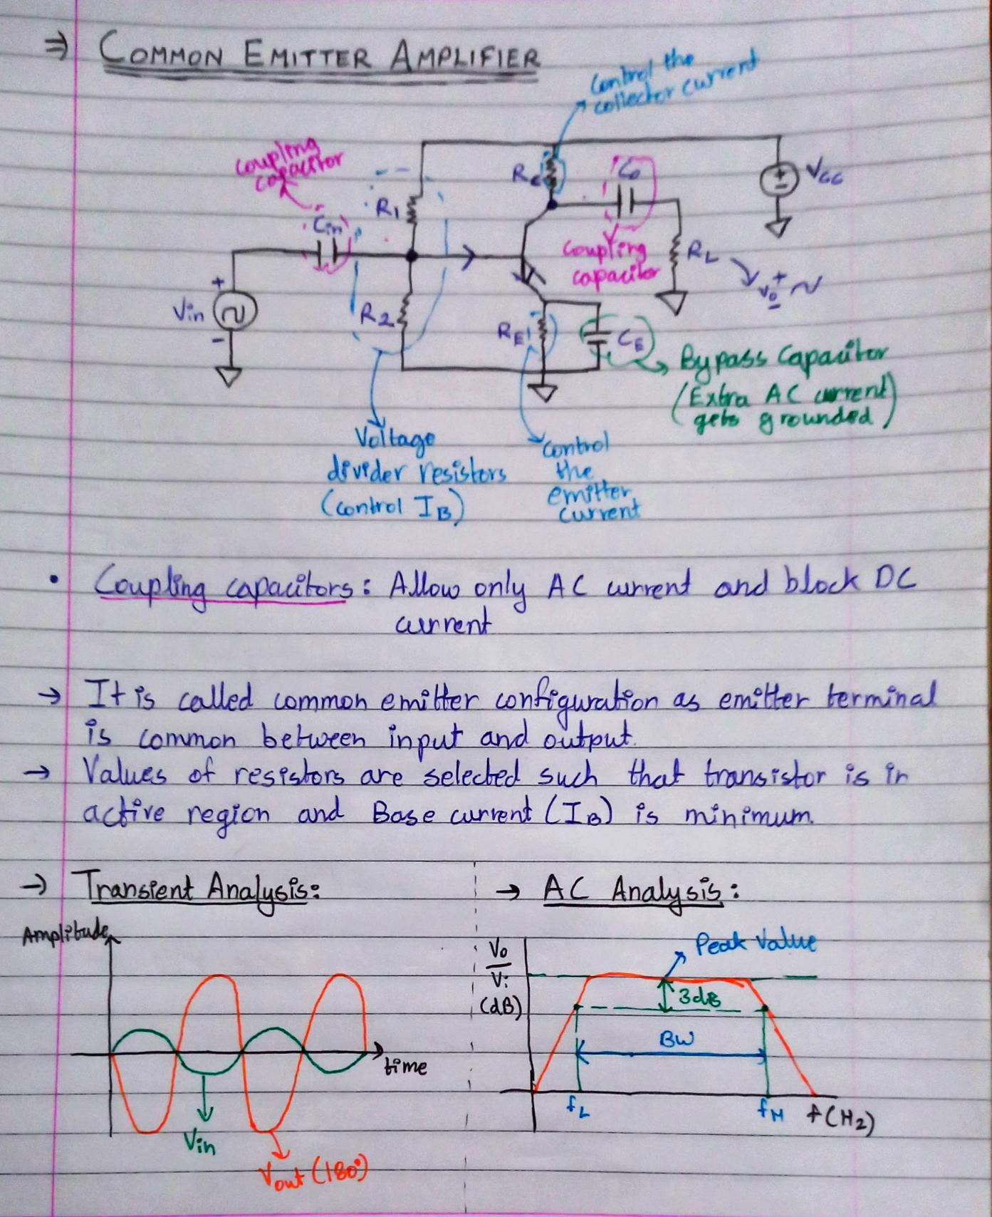

**Simulation Results:**

1. **Transient Analysis**

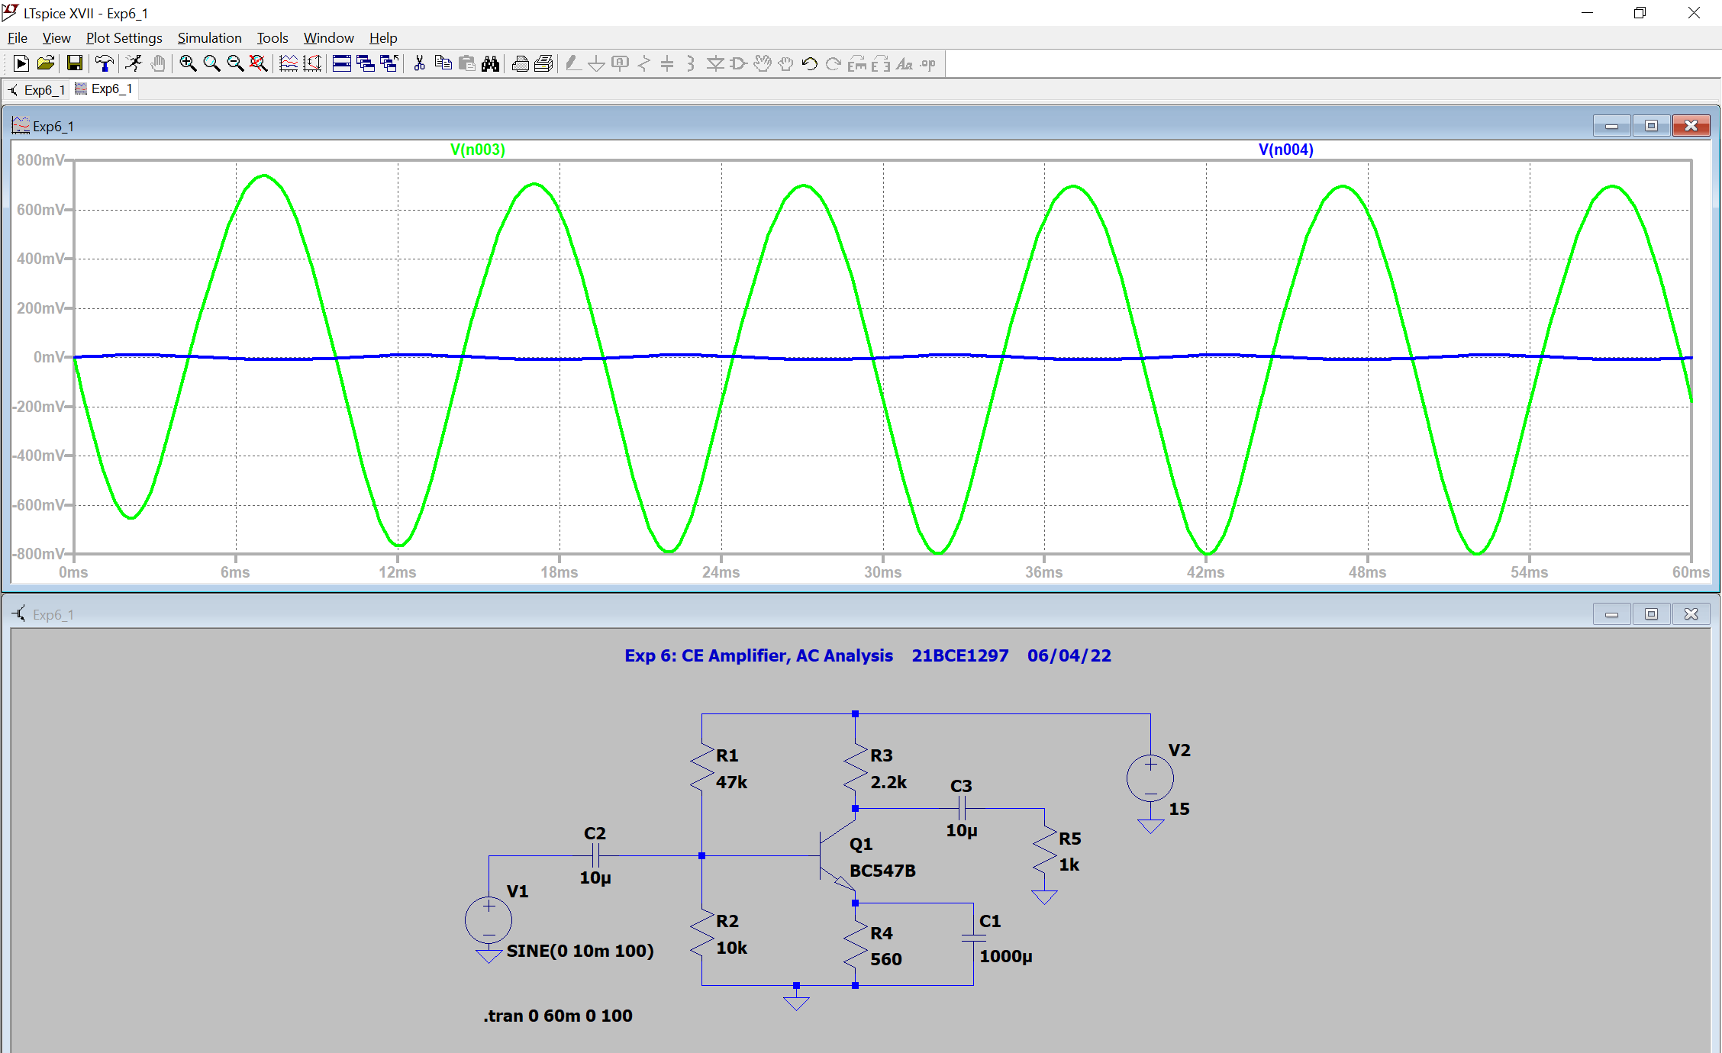

1. **AC Analysis**

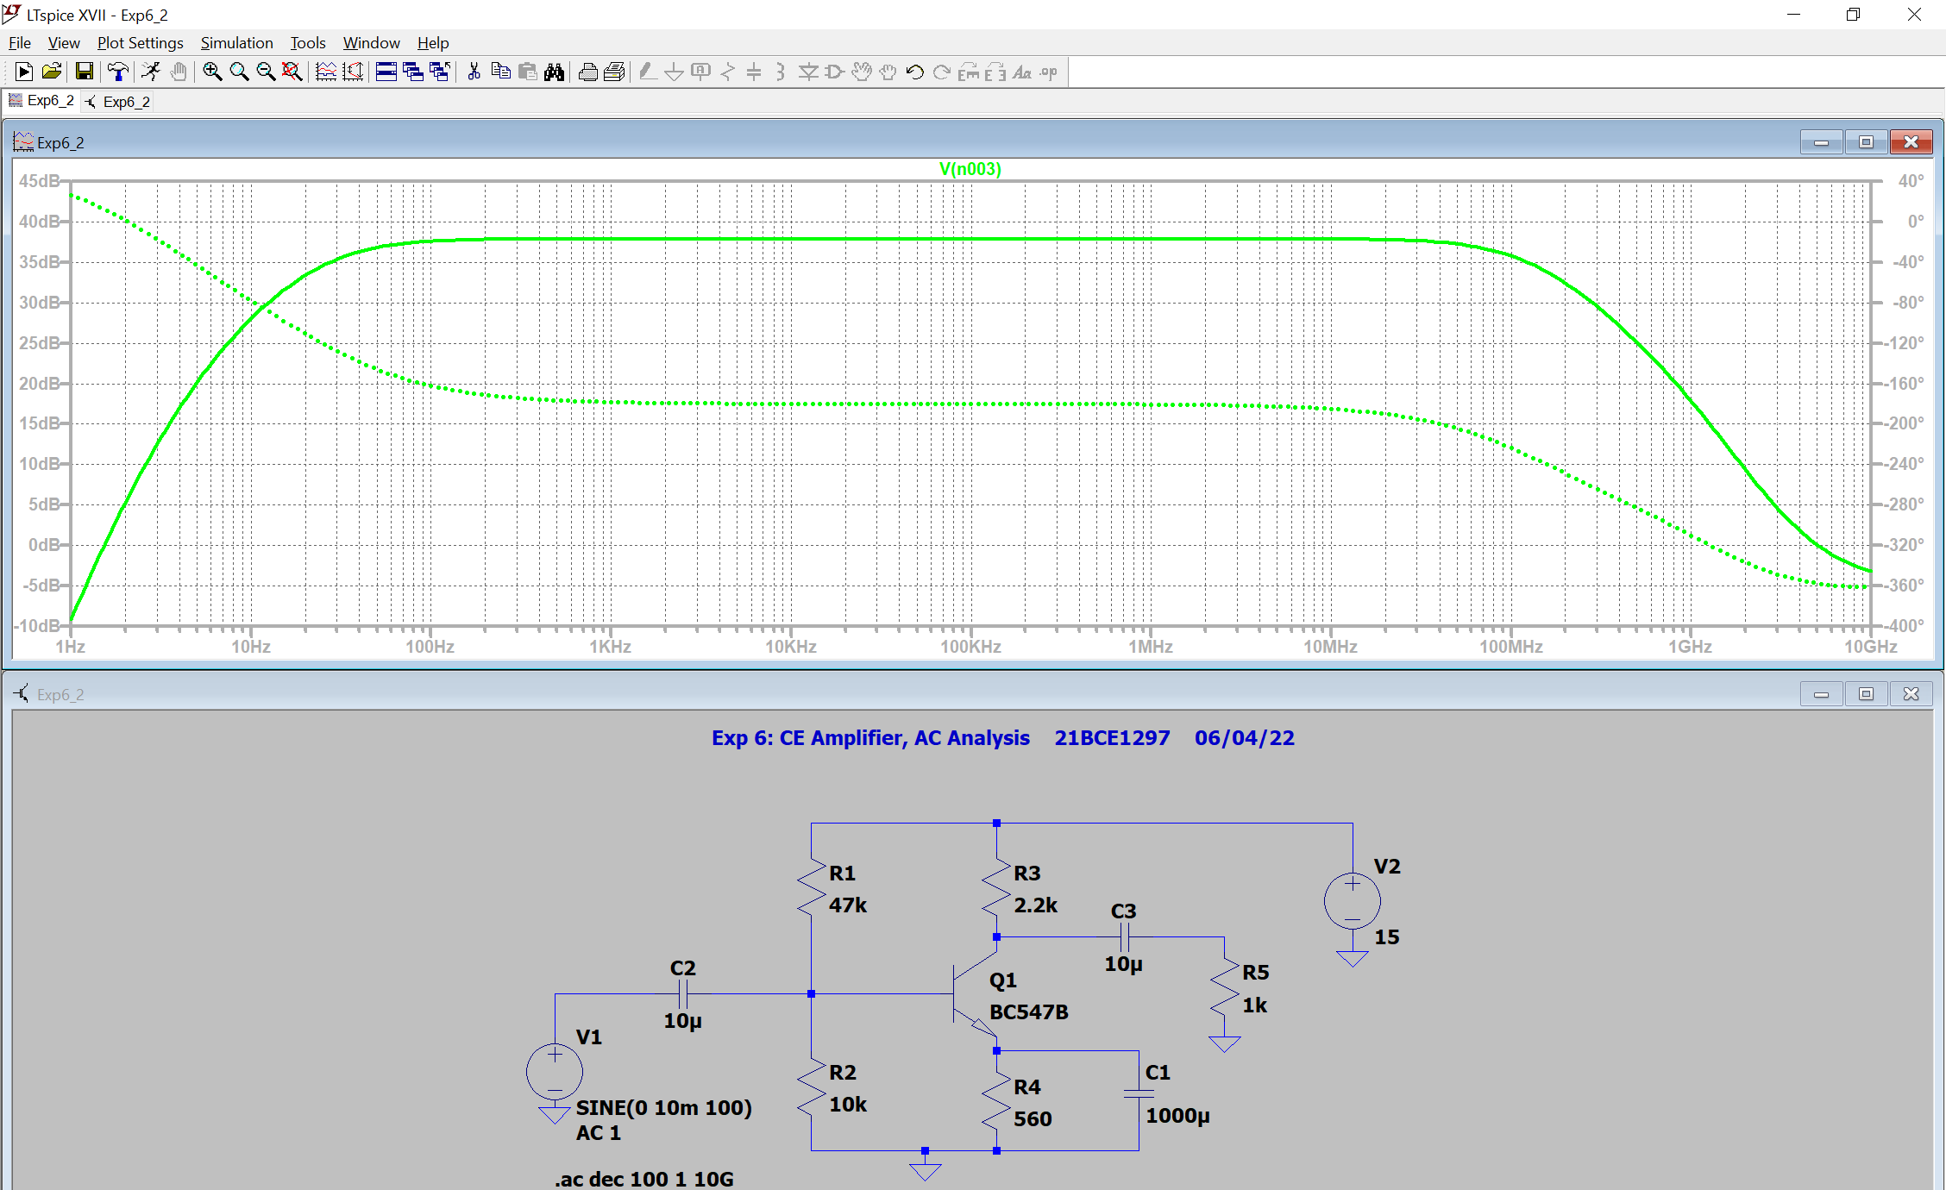

**Conclusion:**

1. **Transient Analysis:**
   1. Gain $=\frac{V_{o}}{V_{i}}=\frac{695.754}{9.497}=73.26$
2. **AC Analysis:**
   1. Peak Value, $\frac{V_{o}}{V_{i}}$ = 37.8 dB
   2. Gain $={10}^{\frac{37.8}{20}}=77.62$
   3. Half Power Values = 37.8 – 3 = 34.8 Db
   4. fL = 26.2 Hz, fH = 129.3 MHz
      1. **Amplifier Bandwidth = fL - fH = 129.29 MHz**
      2. **Bandwidth for Constant Phase = 20MHz - 200Hz = 19.99 MHz**

**Inferences:**

1. It is a common emitter configuration as emitter terminal is common between input and output.
2. Resistors are selected such that transistor remains in active region and base current is minimum.
3. As we can see in transient analysis signal is amplified almost by 73 times.
4. The value of emitter capacitor enhances the amplification of AC signal.
5. Bandwidth is equal to upper limit as lower limit is negligible in comparison.
6. Connect the voltage biasing resistors properly.